Project Design Phase-II
Technology Stack (Architecture & Stack)

Date | 31 January 3035
Team ID
Project Name
Maximum Marks | 4 Marks

Technical Architecture:
The Deliverable shall include the architectural diagram as below and the information as per the table1 & table 2
Example: AI-Powered Weather Forecasting and Early Warning System
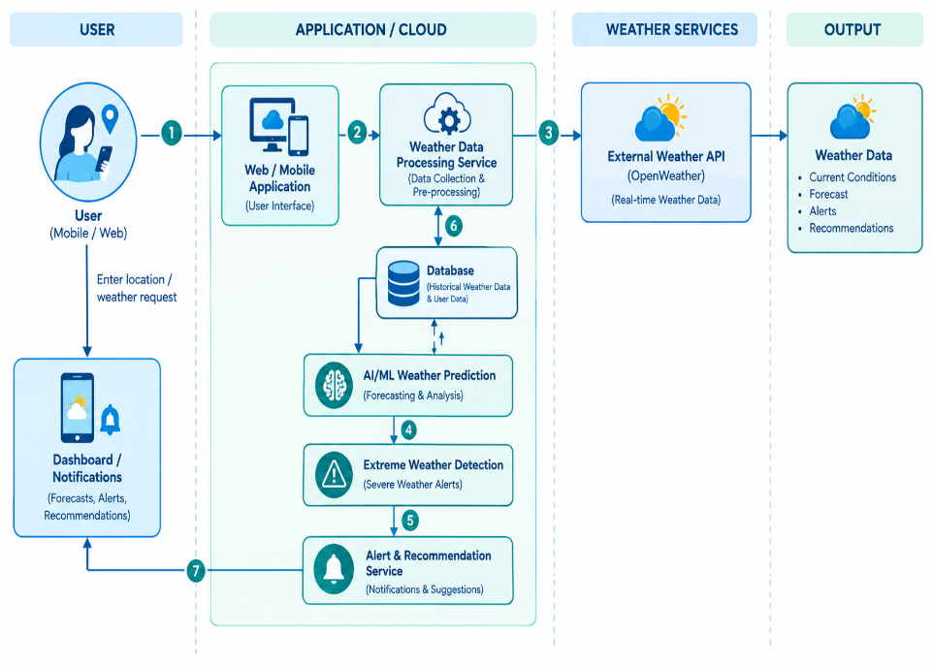
Guidelines:
- Include all major weather-processing and AI/ML components.
- Show Local and Cloud infrastructure clearly.
- Indicate external APIs such as OpenWeather API.
- Show database/storage components.
- Show the connection between weather data and the AI/ML model.
- Show the user interface for accessing weather information.
- Include data collection and preprocessing steps.
- Show weather prediction and analysis processes.
- Include extreme weather detection.
- Show alert and notification services.
- Include weather-based recommendations.
- Show the flow of data between all major components.

Table-1 : Components & Technologies:
S.No. | Component | Description | Technology
 | User Interface | Interface through which users enter their location and view current weather, forecasts, alerts and recommendations. | HTML, CSS, JavaScript / Streamlit
 | Application Logic-1 | Collects weather information from the external weather service and processes the received data. | Python
 | Application Logic-2 | Cleans, analyzes and prepares weather data for forecasting and decision-making. | Python, Pandas, NumPy
 | Application Logic-3 | Generates weather predictions, identifies extreme weather conditions and produces alerts/recommendations. | Python, Machine Learning / AI Model
 | Database | Stores relevant weather records, historical data, user preferences and application information. | MySQL / SQLite
 | Cloud Database | Cloud-based storage can be used for maintaining weather and user data when the system is deployed online. | Cloud Database (optional)
 | File Storage | Stores datasets, trained model files, configuration files and other application resources. | Local File System / Cloud Storage
 | External API-1 | Provides real-time weather information such as temperature, humidity, wind speed and weather conditions. | OpenWeather API
 | External API-2 | Provides additional location or weather-related information if required by the application. | Geolocation API / Maps API (optional)
 | Machine Learning Model | Analyzes weather data and generates predictions or identifies conditions requiring alerts. | Python ML libraries – Scikit-learn / TensorFlow (depending on implementation)
 | Infrastructure (Server / Cloud) | Hosts and runs the application and its supporting services. | Local Server / Streamlit Cloud / Cloud Platform

Table-2: Application Characteristics:
S.No. | Characteristics | Description | Technology
- 1 | Open-Source Frameworks | The application uses open-source technologies for data processing, application development and visualization. | Python, Streamlit, Pandas, NumPy, Scikit-learn
- 2 | Security Implementations | User information and API credentials should be protected. API keys should not be exposed in the source code, and access to application resources should be controlled. | Environment Variables, HTTPS, Authentication, Secure API Key Management
- 3 | Scalable Architecture | The application can be expanded to support more users, locations, weather data and additional forecasting features. Application, prediction and database components can be separated as the system grows. | Python, Streamlit, Cloud Deployment, Database
- 4 | Availability | The application can be deployed on a cloud platform so that users can access weather forecasts and alerts whenever the required external weather service is available. | Cloud Hosting / Streamlit Cloud
- 5 | Performance | Weather data is retrieved through an API and processed before being displayed to the user. Caching and efficient data processing can reduce repeated API requests and improve response time. | Python, Pandas, API Caching, Streamlit Caching

